|  |  |  |  |  |
| --- | --- | --- | --- | --- |
| **National University of Computer and Emerging Sciences, Lahore Campus** | | | | |
| C:\Users\saif\AppData\Local\Microsoft\Windows\Temporary Internet Files\Content.Word\final design.jpg | **Course:** | **Software Engineering** | **Course Code:** | **CS-3009** |
| **Program:** | **BS (Computer Science)** | **Semester:** | **Spring 2024** |
| **Duration:** | **20 Minutes** | **Total Marks:** | **15** |
| **Quiz Date:** | **21-May-24** | **Roll No.** |  |
| **Section:** | **6C** | **Name:** |  |
|  |  |  |  |
|  |  | | | |

Question 1:

In a software engineering scenario, a user interacts with a login system to access a secure application. The user provides their username and password, and upon successful authentication, gains access to the system. Throughout this interaction, the system generates two error messages to handle exceptional conditions that may occur. Furthermore, the system generates three different reports based on the user's actions or specific functionalities. These reports provide valuable insights or data summaries to aid the user in their tasks or decision-making processes. During the session, the user also makes six queries to the system, seeking specific information or requesting actions. The system responds promptly to these queries, ensuring efficient communication and retrieval of data. To support its operations, the system maintains two separate data files that facilitate response generation and processing. These files store relevant information or configurations necessary for the system's functionality. Additionally, the system establishes a connection with an external database. This connection allows the system to access a vast amount of data stored externally, expanding its capabilities and providing users with comprehensive information or resources.

The weighting factors for all the domain values are provided below. Consider simple weighting factor for input and output and complex weighting for remaining functions:

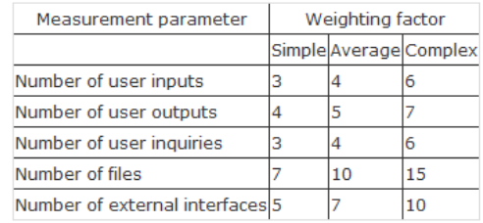

1. Complete the table given below: (10 marks)

|  |  |  |  |
| --- | --- | --- | --- |
| **Information Domain Value** | **Count** | **Weighting Factor** |  |
| External Inputs | 2 | 3 | 6 |
| External Outputs | 5 | 4 | 20 |
| External Inquiries | 6 | 6 | 36 |
| Internal Logical Files | 2 | 15 | 30 |
| External Interface Files | 1 | 10 | 10 |
| Count Total = | | | 102 |

1. Suppose all the value adjustment factors are given an average score of 3. Calculate the function points. (2.5 Marks)

FP= count_total × [0.65 + 0.01 × Σ (*Fi*)]

FP = 102 × [0.65 + 0.01 × 14 × 3]

FP = 102 × 1.07

FP = 109.14

1. Let the average productivity rate be 10 FP/PM. What would be the estimated effort?

(2.5 Marks)

Estimated Effort = $\frac{FP}{Average Productivity}$

Estimated Effort = $\frac{100.58}{10 }$

Estimated Effort = 10.9 person-month or (approx. 11 person-month)